新概念 3 册
Lesson29 Funny or not?

Book
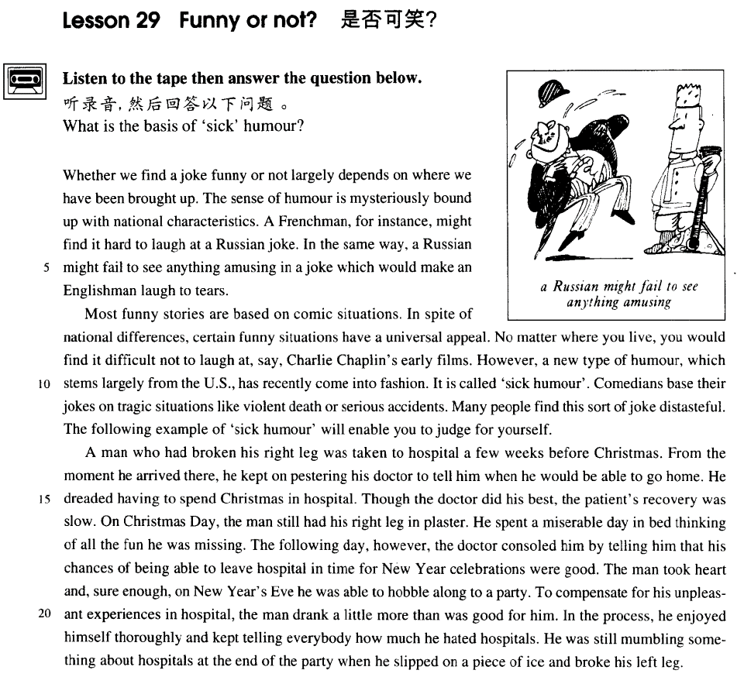

课文
Whether we find a joke funny or not largely depends on where we have been brought up.
我们觉得一则笑话是否好笑，很大程度取决于我们是在哪儿长大的。

The sense of humour is mysteriously bound up with national characteristics.
幽默感与民族有着神秘莫测的联系。

A Frenchman, for instance, might find it hard to laugh at a Russian joke.
譬如，法国人听完一则俄国笑话可能很难发笑。

In the same way, a Russian might fail to see anything amusing in a joke which would make an Englishman laugh to tears.
同样的道理，一则可以令英国人笑出泪来的笑话，俄国人听了可能觉得没有什么可笑之处。

Most funny stories are based on comic situations.
大部分令人发笑的故事都是根据喜剧情节编写的。

In spite of national differences, certain funny situations have a universal appeal.
尽管民族不同，有些滑稽的情节却能产生普遍的效果。

No matter where you live, you would find it difficult not to laugh at, say, Charlie Chaplin's early films.
比如说，不管你生活在哪里，你看查理.卓别林的早期电影很难不发笑。

However, a new type of humour, which stems largely from the U. S. , has recently come into fashion.
然而，近来一种新式幽默流行了起来，这种幽默主要来自美国。

It is called 'sick humour'.
它被叫作“病态幽默”。

Comedians base their jokes on tragic situations like violent death or serious accidents.
喜剧演员根据悲剧情节诸如暴死，重大事故等来编造笑话。

Many people find this sort of joke distasteful. The following example of 'sick humour' will enable you to judge for yourself.
许多人认为这种笑话是低级庸俗的。下面是个“病态幽默”的实例，你可据此自己作出判断。

A man who had broken his right leg was taken to hospital a few weeks before Christmas.
圣诞节前几周，某人摔断了右腿被送进医院。

From the moment he arrived there, he kept on pestering his doctor to tell him when he would be able to go home.
从他进医院那一刻时，他就缠住医生，让医生告诉他什么时候能回家。

He dreaded having to spend Christmas in hospital.
他十分害怕在医院过圣诞。

Though the doctor did his best, the patient's recovery was slow.
尽管医生竭力医治，但病人恢复缓慢。

On Christmas day, the man still had his right leg in plaster.
圣诞节那天，他的右腿还上着石膏，

He spent a miserable day in bed thinking of all the fun he was missing.
他在床上郁郁不乐地躺了一天，想着他错过的种种欢乐。

The following day, however, the doctor consoled him by telling him that his chances of being able to leave hospital in time for New Year celebrations were good.
然而，第二天，医生安慰他说，出院欢度新年的可能性还是很大的，

The man took heart and sure enough, on New Year's Eve he was able to hobble along to a party.
那人听后振作了精神。果然，除夕时他可以一瘸一拐地去参加晚会了。

To compensate for his unpleasant experiences in hospital, the man drank a little more than was good for him.
为了补偿住院这一段不愉快的经历，那人喝得稍许多了一点。

In the process, he enjoyed himself thoroughly and kept telling everybody how much he hated hospitals.
在晚会上他尽情娱乐，一再告诉大家他是多么讨厌医院。

He was still mumbling something about hospitals at the end of the party when he slipped on a piece of ice and broke his left leg.
晚会结束时，他嘴里还在嘟哝着医院的事，突然踩到一块冰上滑倒了，摔断了左腿。

词汇讲解
- largely ['lɑ:dʒli]adv. 在很大程度上，主要地
largely: [英文解释]to a great extent; chiefly
- His success was largely (在很大程度上)due to his hard work.
- The theory was largely(广泛的) adopted.
mostly: in most cases 在大多数情况下
- We’re mostly out on weekends.

- comic ['kɒmɪk] adj. 喜剧的；可笑的
comedy n. 喜剧；喜剧性；有趣的事情
funny adj. 有趣的，好笑的，滑稽的
amusing adj. 有趣的，好玩的；引人发笑的
diverting adj. 有趣的；令人快乐的

tragic adj. 悲剧的；悲痛的，不幸的
tragedy n. 悲剧；灾难；惨案

farcical adj. 滑稽的；闹剧的；引人发笑的
farce n. 闹剧；胡闹；笑剧

dramatic adj. 戏剧的；急剧的；引人注目的；激动人心的
drama n. 戏剧，戏剧艺术；剧本；戏剧性事件

- universal [ju:nɪ'vɜ:sl] adj. 普遍的、世界性的

【区分】
cosmic adj. 宇宙的
cosmos n. 宇宙

【形近】
comic adj. 喜剧的；滑稽的；有趣的
comet n. [天] 彗星
cosmetics n. [化工] 化妆品（cosmetic的复数）；装饰品

【近义】universal
global adj. 全球的；总体的；球形的
international adj. 国际的；两国（或以上）国家的；超越国界的；国际关系的；世界的
world-wide adj. 遍及全世界的
- English has now become an international language. Therefore, if you have a good command of this language, you hold the key to success.

universally adv. 普遍地；
- It is universally known that ...

- comedian [kə'mi:diən] n. 喜剧演员，丑角
comedian n. 喜剧演员；滑稽人物
comedienne n. 喜剧女演员
comedy n. 喜剧
tragedian n. 悲剧演员；悲剧作家
tragedienne n. 悲剧女演员
tragedy n. 悲剧
leading role / part 主角
protagonist n. 主角，主演；主要人物，领导者
leading man 男主角
hero n. 英雄；男主角，男主人公
leading lady 女主角
heroine n. 女主角；女英雄；女杰出人物
supporting role 配角
extra 临时演员

- distasteful [dɪs'teɪstfl] adj. 讨厌的，令人不愉快的
be distasteful to sb. 对某人来说是讨厌的
- It is distasteful to me to say this, but ......
- I hate to say this, but ......

【近义】
表达“令人厌恶的”的词汇：
disgusting disgust
revolting revolt
repellent repel
repulsive repulse

- pester ['pestə(r)] v. 纠缠，一再要求
pester sb. for sth. 为了某事纠缠某人
pester sb. with sth. 用某个东西纠缠某人
- He pestered me with complaints.
- He pestered me for money.

【近义】
harry vt. 折磨；掠夺；骚扰；使苦恼
harass vt. 使困扰；使烦恼；反复袭击
assail vt. 攻击；质问；着手解决

- recovery [rɪ'kʌvərɪ] v. 恢复原状；康复
recovery from ... 从…（不好的）状态中恢复原状
- recovery from illness
- recovery from defeat

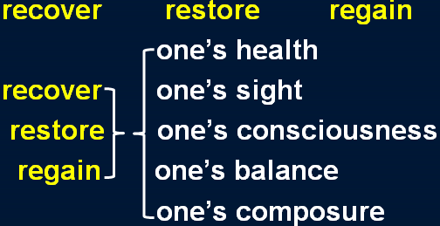

- console [kən'səʊl] v. 安慰，慰问
console sb. for sth. 因为某事安慰某人
console sb. with sth. 用某事安慰某人
- I consoled him for the loss of money.
- I consoled him with money.

comfort vt. 安慰；使（痛苦等）缓和
- comfort a dying man
soothe vt. 安慰；使平静；缓和 vi. 起抚慰作用
- soothe a crying baby
calm sb. down 让人平静下来
condole with sb. 吊慰某人
- The widow’s friends condoled with her at the funeral.

- compensate ['kɒmpenseɪt] v. 弥补，补偿
compensate (sb.) for sth. 弥补某人某事
- Nothing can compensate (him) for his loss.

more than compensate for ... 足以弥补
- 课后题：Lesson 4
- 11．His rise in status more than ___C___ the loss of money. (11.14-15)
(a) pays back
(b) rewards
(c) compensates for
(d) values
- His rise in status more than compensates for the loss of money.

make up for ... 弥补损失
redeem ... = compensate for
offset ... = compensate for

课文讲解

（第一段）

Whether we find a joke funny or not largely depends on where we have been brought up.

语法分析：
Whether we find a joke funny or not（主句从句） largely depends on where（做介词on的宾语从句） we have been brought up.

知识点（1）
语法：whether和if 从句
表示“是否”时不能用 if 的几种情况：
1、主语从句位于句首时，不能用 if
- If she likes the present is not clear to me. X错误
- It is not clear to me if / whether she likes the present. √ （改正，放在句中）
- Whether she likes the present is not clear to me. √ （改正，句首改成whether）
2、引导表语从句时，不能用 if
- The question is if we have enough money. X错误
- The question is whether we have enough money. √改正
3、引导同位语从句时，不能用 if
- You have yet to answer my question if I can count on your help. X错误
- You have yet to answer my question whether I can count on your help. √改正
4、作介词宾语时，不能用 if
- He was worrying about if he had hurt her feelings. X错误
- He was worrying about whether he had hurt her feelings. √改正
5、引导动词不定式时，不能用 if
- I don’t know if to see my doctor today. X错误
- I don’t know whether to see my doctor today. √改正
6、直接跟 or not 时，不能用 if
- Please tell me if or not you agree. X错误
- Please tell me whether or not you agree. √改正
- Please tell me if you agree or not. √改正

知识点（2）
largely: chiefly / to a great extent 很大程度上

知识点（3）
表达“依赖、依靠、取决于”：
depend on ...
rest on ...
rely on...
ride on ...
hinge on ...
lean on ...
be dependent on ...
be based on ...
be built on ...
be founded on ...
be decided by ...
be dictated by ...
be determined by ...
- Whether you find a joke funny or not largely rests / relies / rides / hinges / leans on where we have been brought up.
- Whether you find a joke funny or not is largely dependent / based / built / founded on where we have been brought up.
- Whether you find a joke funny or not is largely decided / dictated / determined by where we have been brought up.

知识点（4）
bring up sb. 拉扯大
- He was brought up by his step-mother.
raise sb. 抚养
foster / adopt sb. 领养某人
adopted son 养子
adoptive parents 养父母
foster-parents 养父母

区分：
be brought up to do 从小就…（用于一般线城市）
- The sad truth is that most of us have been brought up to eat certain foods and we stick to them all our lives.
- We have been brought up to fear insects.

The sense of humour is mysteriously bound up with national characteristics.

知识点（1）
the sense of humour 幽默感
the sense of pride 自豪感
the sense of honor 荣誉感
the sense of accomplishment 成就感
the sense of responsibility 责任感
the sense of superiority 优越感
the sense of inferiority 自卑感

知识点（2）
be bound up with ... 与…紧密相连
be closely connected with ... 与…紧密相连
- Everyone’s future is bound up with the destiny of the Chinese nation.

bind 绑
be bound to do ... 必然会…、肯定会…
- On our road ahead, we are bound to meet with difficulties.

be / feel bound to do ... 觉得必须做某事
- I felt bound to tell him the truth.

be / feel obliged to do ... 觉得必须做某事
- However, as the evidence began to accumulate, experts from the Zoo felt obliged to investigate, for the descriptions given by people who claimed to have seen the puma were extraordinarily similar.

bind sb. to do 约束某人必须做某事
- The Kyoto Protocol binds each country to reduce the emission of greenhouse gases.

A Frenchman, for instance, might find it hard to laugh at a Russian joke.

语法分析：
A Frenchman, for instance（插入语）, might find it（形式宾语） hard（宾语补足语） to laugh at a Russian joke（真正宾语）.

知识点（1）
a Frenchman 泛指法国人，谓语动词用单数
the French 泛指法国人，谓语动词用复数
an Englishman
the English / British

- 课后题：
- 4．___A__, for instance, might find it hard to ... (11.3-4)
(a) The French
(b) A French
(c) A man in France
(d) If you were French

知识点（2）
- No matter where you live, you would find it（形式宾语） difficult（宾语补足语） not to（真正宾语）. laugh at, say, Charlie Chaplin's early films.

In the same way, a Russian might fail to see anything amusing in a joke which would make an Englishman laugh to tears.

语法分析：
In the same way（介词短语当状语）, a Russian might fail to see anything amusing（形容词后置,修饰amusing）in（介词短语当状语） a joke which（定语从句） would make an Englishman laugh to tears.

知识点（1）
表达“同样的”：
In the same way
likewise
similarly
by the same token

知识点（2）
laugh to tears 笑出眼泪
be bored to tears / death 无聊的要哭/要死
laugh one’s head off 大笑（夸张）
clap one’s hands off 鼓掌（夸张）
cry one’s eyes out 哭（夸张）

- 课文写法替换：
- ... which would make an Englishman laugh his head off.

知识点（3）
写作：contrast 对比修辞 （课文第3句和第4局）
- A mother takes twenty years to make a man of her boy, and another woman makes a fool of him in twenty minutes.
- Men always want to be a woman’s first love; women have a more subtle instinct: what they like is to be a man’s last romance.

（第二段）

Most funny stories are based on comic situations.

In spite of national differences, certain funny situations have a universal appeal.

知识点（1）
universal: 【同义替换】international, global, world-wide
appeal: 【同义替换】attraction, charm, fascination
universal appeal : 【同义替换】an international attraction、a global charm、a world-wide fascination
知识点（2）
appeal to sb. 吸引某人
- The idea never appealed to me very much, ...

attract / charm / fascinate sb. 吸引某人
- Cats never fail to fascinate human beings.

形容词形式：
appealing
attractive
charming
fascinating

No matter where you live, you would find it difficult not to laugh at, say, Charlie Chaplin's early films.

语法分析：
No matter where you live（让步状语从句）, you would find it（形式宾语） difficult（宾语补足语） not to（真正宾语，一直到句末） laugh at, say（插入语“比如说”）, Charlie Chaplin's early films.

知识点（1）
No matter where you live = Wherever you live, ......
语法复习：（参见第8课：疑问词 + ever 的含义）
区分：
- 疑问词 + ever 的含义可引导名词性从句；
- no matter只能引导让步状语从句

- Whoever wants to sign up for the course is welcome. √
- No matter who wants to sign up for the course is welcome. X错误
- No matter who wants to sign up for the course, he is welcome. √改正

- Whatever project he works on is always successful.
- No matter what project he works on, it is always successful.

知识点（2）
(let’s) say 比如说（一般用于插入语）
- Why don’t we have a break until, (let’s) say, 10:45?
- Say / Let's say （充当连词，后面that可省略）(that) the journey takes three hours, you'll arrive at 2 o'clock.

However, a new type of humour, which stems largely from the U. S. , has recently come into fashion.

知识点（1）
表达“起源于”：
stem from …
originate in …
have its root in …
- printing stems from China.
- printing originates in China.
- printing has its root in China.

arise from ... (倒霉的事)源自于…（摩擦、冲突、纠纷…）
- The argument arose from misunderstanding.

come / hail from ... 来自于…
- I come / hail from China.

知识点（2）
come into fashion 流行起来
- Miniskirts have come into fashion.

be in fashion 正在流行
be out of fashion 过时
fashionable （adj. 流行的） clothes / ideas / hairstyles …

知识点（3）
come into 进入…状态
come into fashion 开始流行
come into use 开始使用
- Computers first came into use in the early 1950s.
come into effect 开始生效
- The new seat-belt regulations came into effect last week.
come into blossom 开始开花
- The trees are late coming into blossom this year.
come into being 开始存在
- Up to now, historians have assumed that calendars came into being with the advent of agriculture, …

It is called 'sick humour'.

Comedians base their jokes on tragic situations like violent death or serious accidents.

知识点（1）
课文写法替换：
- Comedians build their jokes on tragic situations ...
- Comedians found their jokes on tragic situations ...

知识点（2）
like = 【书】such as

Many people find this sort of joke distasteful. The following example of 'sick humour' will enable you to judge for yourself.

知识点（1）
课文写法替换：
- Many people find this sort of joke unpleasant / disgusting / repellent / revolting / repulsive. （形容词替换）
- Many people dislike / hate / despise / abhor / detest / loathe / abominate this sort of joke. （动词替换）
- This sort of joke repels / revolts / repulses / disgusts / sickens many people. （主语替换）

知识点（2）
表达“下面的例子”：
the following example
the ensuing example
the under-mentioned example
the example below

表达“上面的例子”：
the previous example
the preceding example
the above-mentioned example
the example above

知识点（3）
enable sb. to do 使某人能够…
- They devise hundreds of competitions which will enable us to win huge sums of money.
allow / permit sb. to do （人做主语）允许某人做…/（事物做主语）使某人能够…
make it possible for sb. to do 是某人能够…
- Radio and television have made it possible for advertisers to capture the attention of millions of people in this way.

- 课文写法替换：
- ... will allow / permit you to judge for yourself.
- ... will make it possible for you to judge for yourself.

知识点（4）
do sth for oneself 亲自做某事
- So great is our passion for doing things for ourselves, that we are becoming increasingly less dependent on specialized labor.

（第三段）

A man who had broken his right leg was taken to hospital a few weeks before Christmas.

语法分析：
A man who had broken his right leg（定语从句） was taken to hospital a few weeks before Christmas（时间状语）.

知识点（1）
- 课文写法替换：
- A man whose right leg had been broken ......

知识点（2）
表达“去医院”：强调功能不能加冠词
take sb. to hospital
send sb. to hospital
go to hospital

表达“去住院”：
be in hospital
be hospitalized

表达“出院”：
leave hospital

知识点（2）
医院相关：
the outpatient department (OPD) 门诊
the inpatient department (IPD) 住院部
casualty 【英】急诊室
emergency room (ER) 【美】急诊室

From the moment he arrived there, he kept on pestering his doctor to tell him when he would be able to go home.

语法分析：
From the moment he arrived there（定语从句,修饰moment）（时间状语）, he kept on pestering his doctor to tell him when he would be able to go home（tell的宾语从句）. （to后，目的状语）

知识点（1）
表达“自从”：
- from没有时态限制
- From the moment (when) he arrived there … （省略when，定语从句）
- From the moment (at which) he arrived there …（省略at which，关系副词）
- From the moment (that) he arrived there …（省略that，关系副词）
- From the moment (/) he arrived there … （空，省略when）

- since 要用完成时
- Since the moment he arrived there, he had kept on pestering ...

知识点（2）
keep (on) doing 不停的做某事…
- Why do you keep (on) making the same mistakes?
- How can I explain if you keep (on) interrupting me?
- In the process, he enjoyed himself thoroughly and kept telling everybody how much he hated hospitals.

He dreaded having to spend Christmas in hospital.

知识点（1）
dread + n. / doing 害怕某事（发生）
- She dreads getting old.
dread to do 一做某事就害怕
- I dread to think what will happen if I fail.
- She dreads to get old. X错误

Though the doctor did his best, the patient's recovery was slow.

表达“竭尽全力做某事”：
do / try one’s best to do
do / try one’s utmost to do
do everything / all one can to do
- 课后题：Lesson29
- 9.Though the doctor ___D___... (1.15)
(a) worked very well
(b) could not have been better
(c) was extremely skilled
(d) did all he could 竭尽全力

give one’s all to do 竭尽全力
spare no effort to do 不遗余力
go all out to do 竭尽全力
go to great lengths to do 竭尽全力做某事
- The man went to great lengths to prove that the diamonds were real.

On Christmas day, the man still had his right leg in plaster.

知识点（1）
at Christmas 介词“at”表示期间
on Christmas Day 介词“on”表示当天
on Easter Day
on weekends 周末 【美】
at weekends 周末 【英】
- The only regular visitors to the monastery in winter are parties of skiers who go there at Christmas and Easter.

知识点（2）
- 课文写法替换：
- ..., the man’s right leg was still in plaster.

He spent a miserable day in bed thinking of all the fun he was missing.

语法分析：
He spent a miserable day in bed thinking of all the fun he was missing（定语从句，修饰missing）. （伴随状语）

The following day, however, the doctor consoled him by telling him that his chances of being able to leave hospital in time for New Year celebrations were good.

语法分析：
The following day（时间状语）, however（插入语）, the doctor consoled him by telling him that his chances of being able to leave hospital in time for new year celebrations（介词短语，修饰chances） were good. （that后到结尾，宾语从句）（by后到结尾，方式状语）

知识点（1）
chance 可能性
- The following day, however, the doctor consoled him by telling him that his chances of being able to leave hospital in time for new year celebrations were good（可能性大）.

- As she is not rich, the chances that she will ever be able to afford such purchases are remote（可能性小）; but she is never sufficiently strong-minded to be able to stop the practice.

one’s chances of doing … are good/high 某人做某事的可能性大
one’s chances of doing … are small/slight/remote 某人做某事的可能性小
the chances that … are good/high
the chances that … are small/slight/remote

- 造句：他赢得这次比赛的可能性很小。
- His chances of winning the game are remote.
- The chances that he will win the game are remote.

The man took heart and sure enough, on New Year's Eve he was able to hobble along to a party.

知识点（1）
take heart = be encouraged 收到鼓舞
lose heart 灰心丧气
辨析：lose one’s heart to ... 爱上某人
sure enough 果然
as expected 果然

知识点（2）
eve 重要日期的前一夜

知识点（3）
along 课文中不是介词，表示向前

To compensate for his unpleasant experiences in hospital, the man drank a little more than was good for him.

语法：than后直接加谓语动词
than was good for him
... than （what） was good for him.
- It seems that man was making a real effort to understand the seasons 20,000 years earlier than has been supposed.

- 考试真题：
- The project requires more labor than ___A___ because it is extremely difficult.
A．has been put in
B．have been put in
C．being put in
D．to be put in

- 考试真题：
- We often advise him not to drink more wine ___B___ is good for his health.
A．as
B．than
C．that
D．but

- 考试真题：
- The experiment requires more money than ___C___.
A．have been put in
B．being put in
C．has been put in
D．to be put in

- 考试真题：
- The indoor swimming pool seems to be a great deal more luxurious than ___A__.
A．is necessary
B．being necessary
C．to be necessary
D．it is necessary

In the process, he enjoyed himself thoroughly and kept telling everybody how much he hated hospitals.

语法分析：
In the process（时间状语）, he enjoyed himself thoroughly and kept telling everybody how much he hated hospitals（宾语从句）.

知识点（1）
..., he had a good / great time ... 过的很开心

知识点（2）
- 课文写法替换：
- ... kept telling everybody to what extent he hated hospitals.

- To what extent do you love her? I’ll die for her.

He was still mumbling something about hospitals at the end of the party when he slipped on a piece of ice and broke his left leg.

语法分析：
He was still mumbling something about hospitals（后置定语,修饰something） at the end of the party when he slipped on a piece of ice and broke his left leg（时间状语）.

知识点（1）
语法：主句 (进行时 / be about to do) + when ... “when”应译为“这时”或“突然； （罕见句型：句子的重点信息在when引导的从句里）

- He was still mumbling something about hospitals at the end of the party when he slipped on a piece of ice and broke his left leg.
- The idea never appealed to me very much, but one day, after a heavy shower, I happened to be walking in my garden when I noticed a huge number of snails taking a stroll on some of my prize plants.
- The Karen had been sailing in a convoy to Russia when she was torpedoed by an enemy submarine.
- The morning passed rapidly and Frank was about to leave when he noticed a large packing case lying on the floor.

知识点（2）
slip 滑
slip on a piece of ice 在冰上滑倒
trip over a stone 在石头上绊倒
a slip of the pen 小失误
a slip of the tongue 口误

